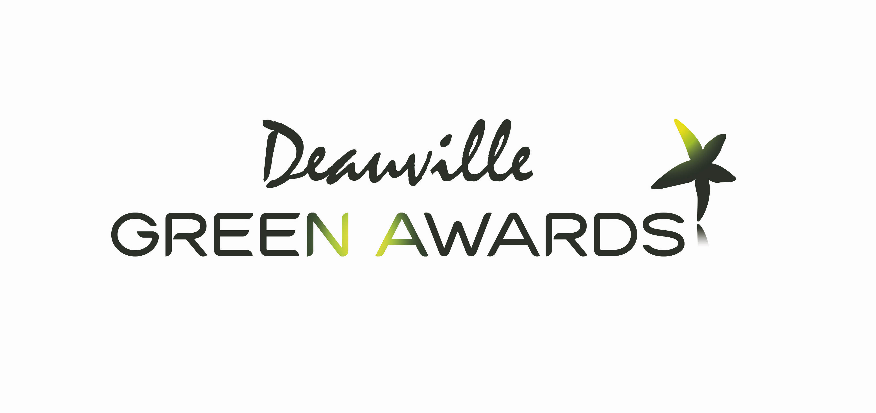
Deauville Green Awards 2017: record breaking year for the leading festival in green, socially responsible communication and audio-visual productions!

With 370 films from around the world and hundreds of professionals expected, the key figures in the future of green, socially responsible communication will meet in Deauville on 27 and 28 June.

For this promising 6th edition, more than 100 finalist films from all 5 continents selected by the international jury will be screened in the presence of their teams in an attempt to win the prestigious Golden Green Award. For 6 years this prize has rewarded excellence in the field of audio-visual productions and communication on sustainable development, eco-innovations and social responsibility.

The festival will bring together key players in the sector such as the World Bank, BBC, French Ministry of Culture and Communication, IDF Film Commission, Deutsche Welle, Enedis, Euronews, RTÉ, NHK, National Parks, ITV, World Television, Radio Canada, YLE Finland, Sveriges Television, Ushuaia, GGGI, WWF, innovative start-ups and numerous journalists, producers, directors and agencies.

For this 6th edition, in addition to the sessions of networking, cocktails, meals and after-parties, a rich program awaits the professionals with:
> many inspiring expert roundtables such as:
- "Behind homo numericus": the possibilities offered by technological innovation
- "Tomorrow, 9 billion locavores?" : New ways to feed the planet
- "Towards the end of hypermobility?": How to rethink our relationship with transport
- and a screening and debate on the protection of coastlines
> the hundred finalist films divided into 3 competitions screened in the presence of the teams
> the competition 2017 and its 370 films from the 5 continents in free access within the Media Center.
> numerous screenings offered to schoolchildren and the general public
> workshops: Ecoprod, Climate Outreach, Opsomai, AXS Music, Ministry of Culture, BNF etc.

Climate Outreach, a UK-based NGO that specialises in the communication of climate change, will be holding workshops discussions on the efficiency of visuals for climate communication. Ecoprod will be hosting a workshop, with its counterparts from the BBC and german Green Film Shooting, on how to make the audio-visual production process more environmentally friendly.

Jean Jouzel, who won the Nobel prize with the IPCC in 2007, developed this series of workshops regarding innovation as president of the scientific committee of the festival. His motto: “When one seeks, it is not enough to find, you must make it known!“. This has precisely been the essence of the festival for the past 6 years: the use of images in order to reveal, denounce, uncover, value, explain and educate the biggest number of people possible.

In addition to this, many important public figures support the festival in its effort to raise awareness of good practices through the use of images: Arnold Schwarzenegger, Jerry Brown (current governor of California), and Jane Goodall (famous primatologist) who took part in the COP21, the climate conference at the Grand Palais in Paris; and also Jean-Michel Cousteau and Bertrand Picard.

Starting from now, all professionals can book a pass for the festival and be part of the experience.

See you on June 27th and 28th at the Villa Le Cercle of Deauville (CID).

